Requirements

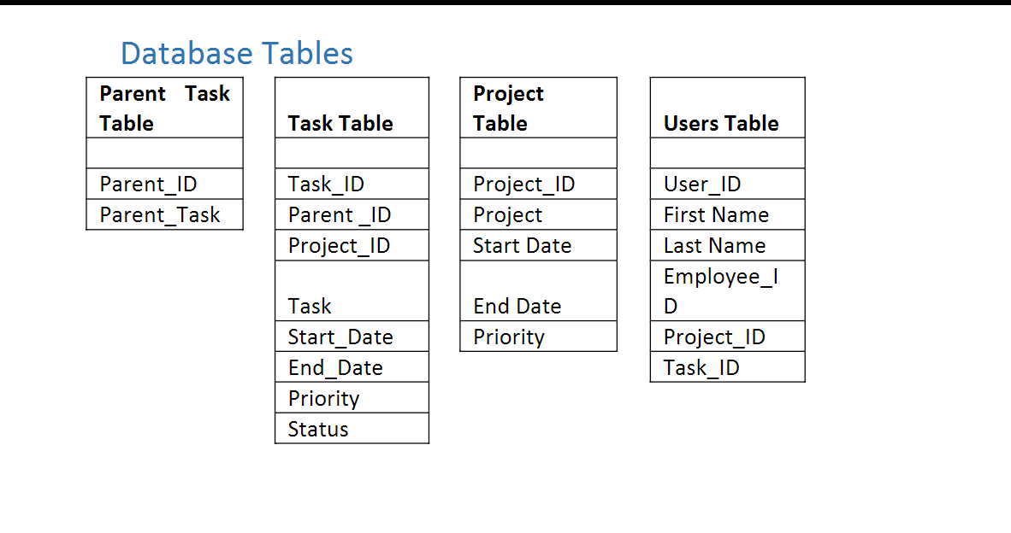

**Add User**

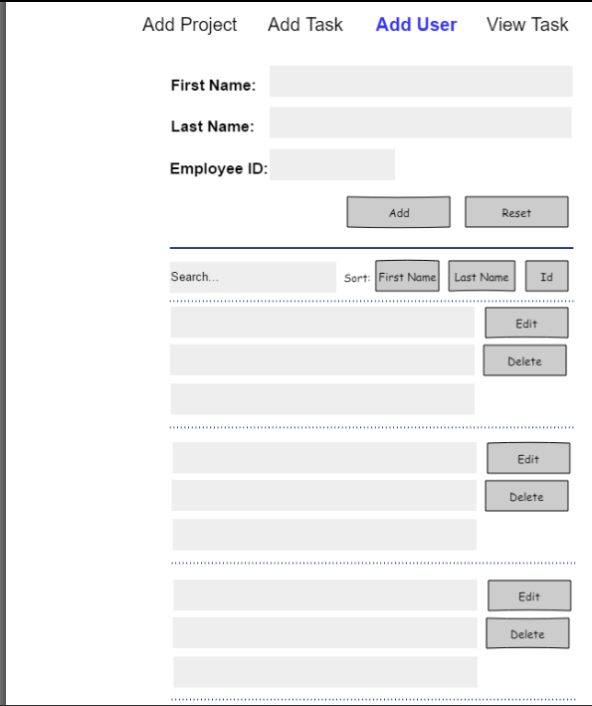

**Add Project**

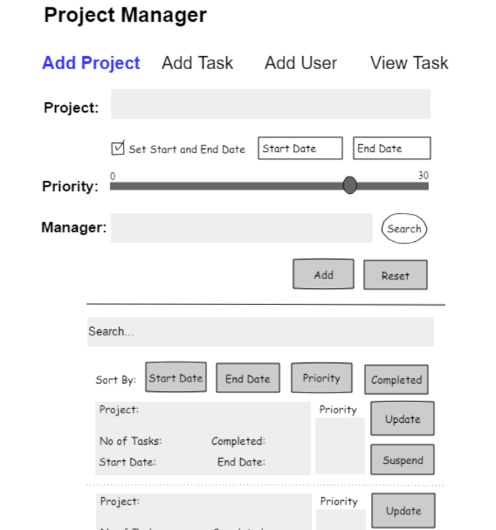

**Add Task**

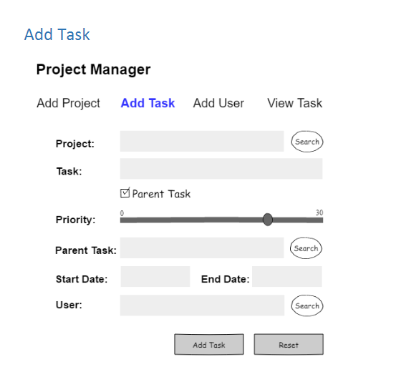

**View Task**

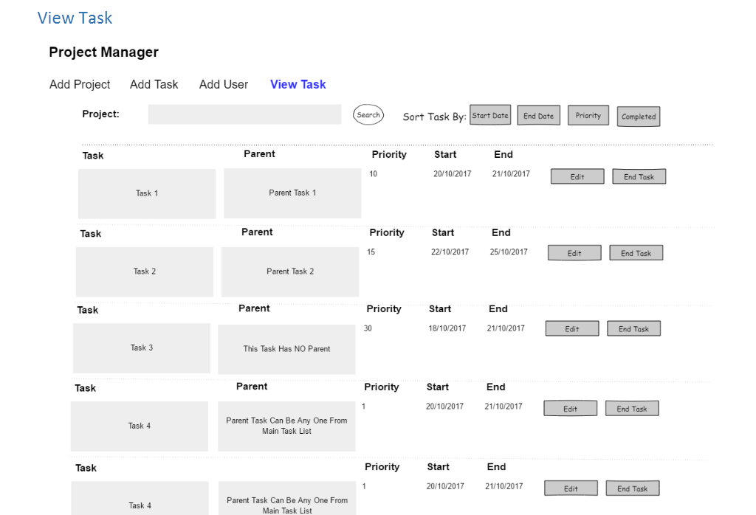

Requirement 1:

Add User Screen

1. Create Add User Screen UI
2. Page should have header.
3. Page should be responsive
4. Navigation to “Add Project” Page, “Add Task” Page, “View Task” Pages should be asper SPA standards.
5. This page will open when user clicks on “Add User” link.
6. Page is divided into 2 sections:

i. Add User

ii. View User

f. Add User

i. Fields to be input by the user are first name, last name and employee id.

ii. Proper validations should be in place to prevent user from entering blank first name or last name and employee id. All fields are mandatory.

iii. Clicking on add button will create a JSON object and send it to the restful API for saving the user information in the database.

iv. Each new user which is updated in the database via add user section will be automatically updated in real time in view user section.

g. View User

i.It will list all the users in the list view.

ii. Each user information is grouped into list group (bootstrap class)

iii. Each user information contains first name, last name and employee id.

iv.It will alsohave edit and delete button.

v.Clicking on edit button will populate the user information in the top add user form. The add button at this instance will change to update button.

vi.Clicking on the update button will update only this record in the database via POST method call to restful API.

vii.This section also has 3 buttons, each for sorting the users by their first name,last name and employee id.

viii.It also has a search filter to search particular user from the list of users available in the list

Requirement 2:

Add Project Screen

2.

Create Add Project Screen UI

a.

Page should have header.

b.

Page should be responsive

c.

Navigation to “Add Project” Page, “Add Task” Page, “View Task” Pages should be as

per SPA standards.

d.

This page will open when user clicks on “Add Project”

link.

e.

Page is divided into 2 sections:

i.

Add Project

ii.

View Project

f.

Add Project

i.

Fields to be input by the user are project title.

ii.

If ‘set start and end date’ is checked, then only input fields for start date and

end date should be enabled, else they are disabl

ed. If enabled, then default

start date should be present date and default end date should be 1 day

ahead of present date.

iii.

If user is selecting the start and end date of his/her preference, then proper

validation should be in place for checking that end da

te is not before start

date.

iv.

HTML5 Input type for start date and end date is date type.

v.

Priority is set using range control. By default the priority is set to 0.

vi.

Proper validations should be in place to prevent user from entering blank

project.

vii.

The user wi

ll add manager to the project by clicking on the search button.

List of all the users which are added in the application will be available for

selection in bootstrap modal box. Modal box will also have filter to search

for users. User will be able to selec

t any one user and assign it as manager.

This field is un

-

editable.

viii.

Clicking on add button will create a JSON object and send it to the restful API

for saving the project information in the database.

ix.

Each new project which is updated in the database via ad

d project section

will be automatically updated in real time in view project section.

g.

View Project

i.

It will list all the projects in the list view.

ii.

Each project information is grouped into list group (bootstrap class)

iii.

Each project information contains

project name, no of tasks in the project,

number of tasks completed, start date of the project, end date of the project

and priority.

iv.

It will also have edit and suspend button.

v.

Clicking on edit button will populate the project title and other details in th

e

top add project form. The add button at this instance will change to update

button.

vi.

Clicking on the update button will update only this record in the database

via POST method call to restful API.

vii.

This section also has 4 buttons, each for sorting the pro

ject names by start

date, end date, priority and completed status.

Requirement 3: Add Task Screen

1.

Create Add Task Screen UI.

a.

Page should have header.

b.

Page should be responsive

c.

Navigation to “Add Project” Page, “Add Task” Page, “View Task” Pages should be a

s

per SPA standards.

d.

This page will open when user clicks on “Add Task” link.

e.

The user will select the project for which tasks are required to be added by clicking

on the search button. List of all the projects which are added in the application will

be av

ailable for selection in bootstrap modal box. Modal box will also have filter to

search for projects. User will be able to select any one project. This field is un

-

editable.

f.

Next, user can add the task to the project.

g.

Proper validation should be in place t

o check if this field is empty.

h.

If this task is parent task, then remaining fields i.e. priority, parent task, start date

and end date will be disabled. User will be able to add title for parent task only.

i.

Next, priority for the task can be set using range

control in HTML5.

j.

Next, parent task can be searched and linked. This field is un

-

editable. It is not

mandatory.

k.

Next, start date and end date can be set using HTML5 date input type.

l.

By default, date of present day is set as start date. Date of next date

to present date

is set as end date. End date can never be before start date.

m.

The user will add user to the project by clicking on the search button. List of all the

users which are added in the application will be available for selection in bootstrap

modal

box. Modal box will also have filter to search for users. User will be able to

select any one user and assign it as task owner. This field is un

-

editable.

n.

Once, all fields are filled with information, user can click on add button to convert

the data to JS

ON format and send it to rest API to POST to database.

Requirement 4: View Task Screen

1.

Create View Task Screen UI.

a.

Page should have header.

b.

Page should be responsive

c.

Navigation to “Add Project” Page, “Add Task” Page, “View Task” Pages should be as

per SPA

standards.

d.

This page will open when user clicks on “View Task” link.

e.

The user will select the project for which tasks are required to be viewed by clicking

on the search button. List of all the projects which are added in the application will

be available

for selection in bootstrap modal box. Modal box will have search filter

to search for projects. User will be able to select any one project. This field is un

-

editable.

f.

Once the project is selected, all its tasks along with parent

-

task or no

-

parent

-

task are

displayed in the grid view along with priority, start date and end date.

g.

This screen will also have edit task and end task button.

h.

Clicking on end task will end the task to set its status to complete.

i.

Clicking on edit task will open the edit task screen w

hich will have same rules as that

of add task. User will not be able to change the project, parent task status on edit

task screen.

j.

User will only be able to edit task description, priority, change/remove parent task,

change start date and end date on edit

task screen.

k.

Clicking on update will post the changes to database via rest api.